MADYA BINTANG NUGROHO
NIM. 20151111043
DOSEN PEMBIMBING
Drs. Wijayadi, M.Pd.
Waode Hamsia, S.Pd., M.Pd.

SKRIPSI
PROGRAM STUDI PENDIDIKAN BAHASA INGGRIS
FAKULTAS KEGURUAN DAN ILMU PENDIDIKAN
UNIVERSITAS MUHAMMADIYAH SURABAYA
2019
TEACHING NARRATIVE TEXT WITH COMPUTER-MEDIATED COMMUNICATION THROUGH COLLABORATIVE APPROACH AT SMA MUHAMMADIYAH 10 SURABAYA

umsurabaya
Universitas Muhammadiyah Surabaya

TEACHING NARRATIVE TEXT WITH COMPUTER-MEDIATED COMMUNICATION THROUGH COLABORATIVE APPROACH AT SMA MUHAMMADIYAH 10 SURABAYA

COVER

A THESIS

Submitted for Fulfillment of Requirements The Degree of Sarjana Pendidikan

MADYA BINTANG NUGROHO
NIM. 20151111043

ENGLISH EDUCATION DEPARTMENT
FACULTY OF TEACHER TRAINING AND EDUCATION
MUHAMMADIYAH UNIVERSITY OF SURABAYA
2019
MOTTO:

“GREATER THE SUFFERING, GREATER THE PEACE”

DEDICATION:
This research is dedicated to my family and people surrounding of my life. Thank a lot of your love, support, guidance, and pray. May Allah bless you.

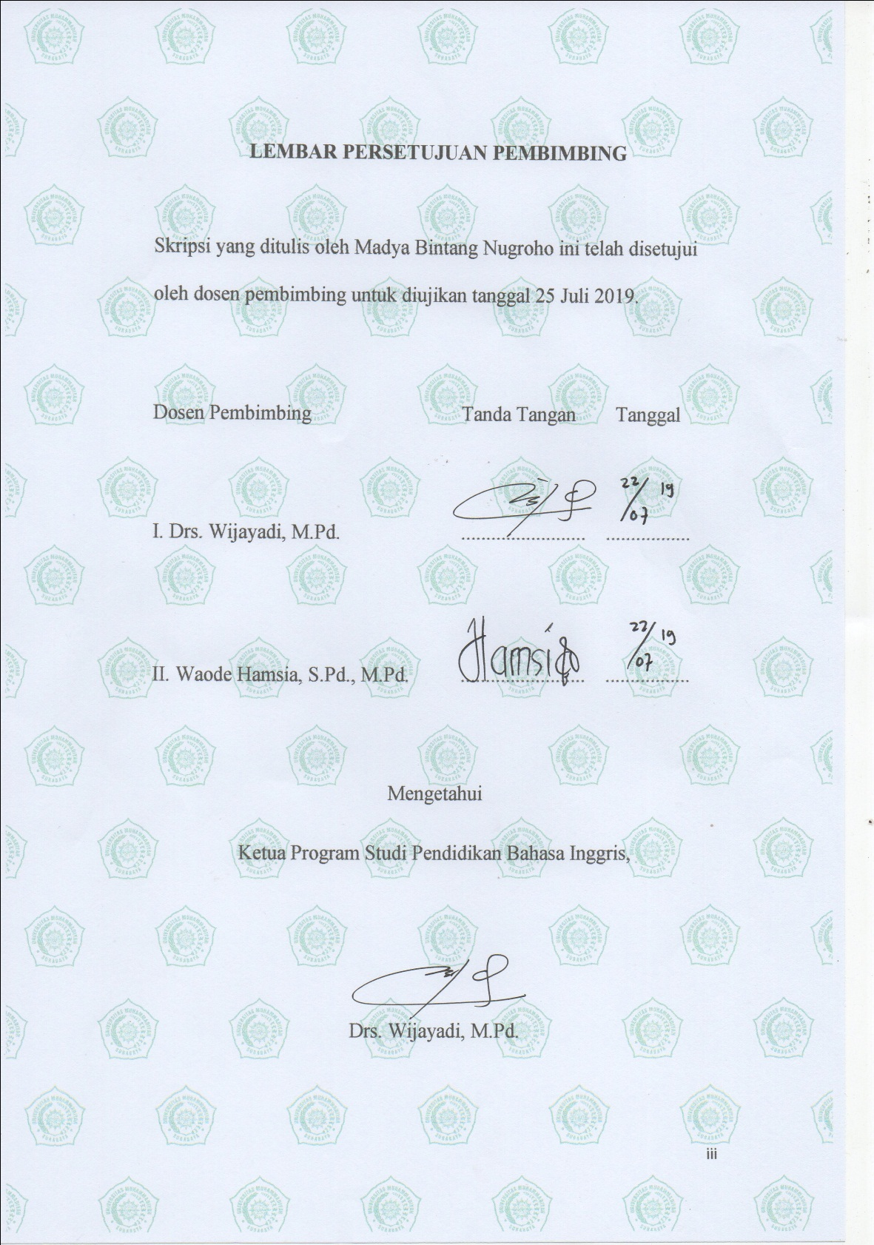
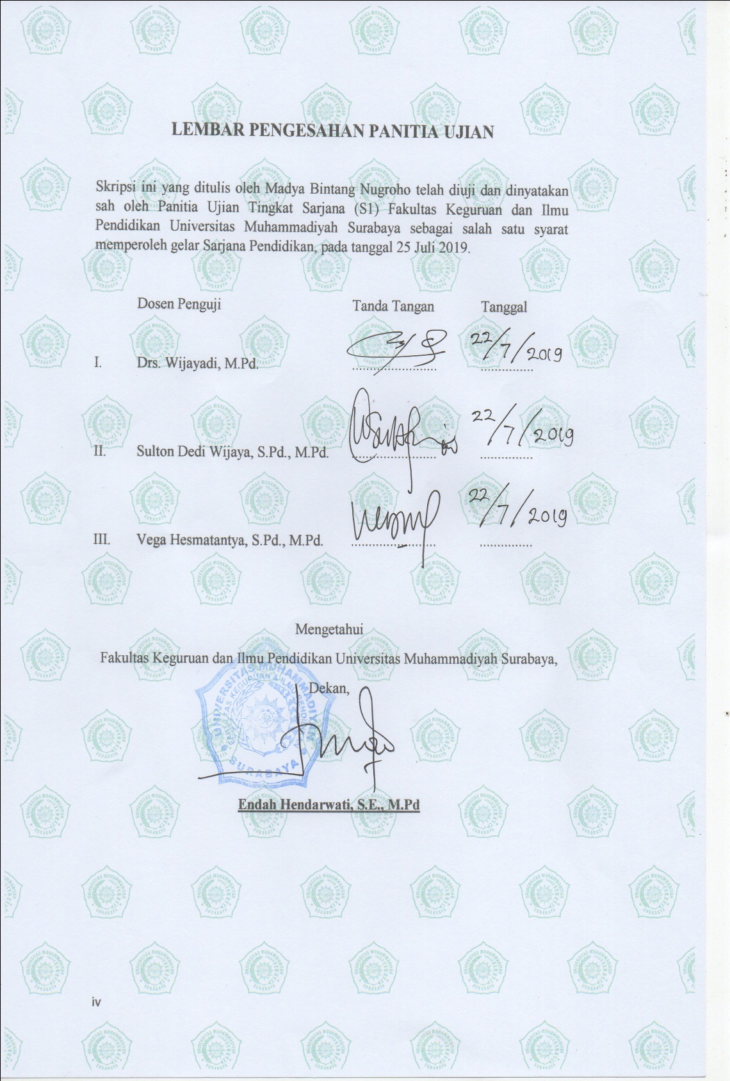
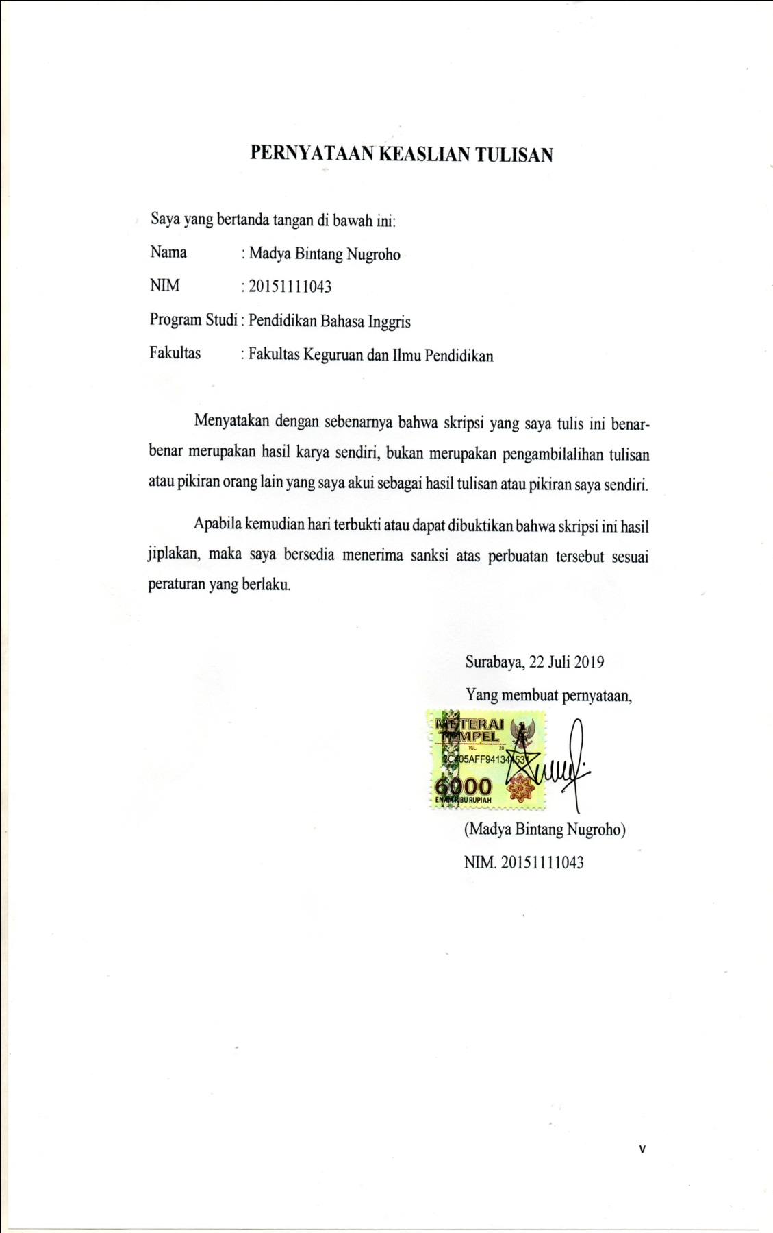

ACKNOWLEDGMENT
Alhamdulillah, all praises to Allah, the God of Universe for all blessings and love. Researcher was able to finish this research entitled “Teaching Narrative Text withComputer-Mediated Communication through Collaborative Approach” at SMA Muhammadiyah 10 Surabaya”. Love and peace be upon our Prophet Muhammad SAW, his family, and his companions – the Greatest Leader of all time.
In this occasion, the researcher would like to express the deepest thanks for helping him in the process of conducted this research. The researcher believe that this research would not completed without the helps, supports, and suggestions from several sides. Researcher also would like to express thanks sincerely for researcher’s family who always give support, spirit, and moral encouragement in the process of his study.
Researcher’s gratitude also goes to those who guide him in the process of his study, namely:
- Drs. Wijayadi, M.Pd, The Head of English Department and also The First Advisor.
- Waode Hamsia, S.Pd., M.Pd, The Second Advisor.
- All of lectures in English Department for their knowledge, motivation, and patience during his study at Universitas Muhammadiyah Surabaya.
- Ust. Maulana Mas’udi, Lc, M.Pd., The Lecture of Islamic Studies for the kindness and knowledge. May Allah bless you in a whole your life.

Surabaya, July 22nd 2019
The Researcher,

Madya Bintang Nugroho
TABLE OF CONTENTS
Pages
COVER i
MOTTO ii
LEMBAR PERSETUJUAN PEMBIMBING iii
LEMBAR PENGESAHAN PANITIA UJIAN iv
PERNYATAAN KEASLIAN TULISAN v
ABSTRACT vi
ABSTRAK vii
ACKNOWLEDGMENT viii
TABLE OF CONTENTS ix
CHAPTER I INTRODUCTION 1
A. Background of the Study 1
B. Statement of the Problem 3
C. Objectives of the Study 3
D. Significance of the Study 3
E. Scope and Limitation 4
F. Definition of Key Terms 4
CHAPTER II LITERATURE REVIEW 6
A. Literature Review 6
B. Previous Studies 14
CHAPTER III RESEARCH DESIGN 16
A. Research Design 16
B. Setting of the Research 18
C. Source of the Data 18
D. Research Instruments 19
E. Research Procedures 20
F. Collect of the Data 20
G. Analysis of the Data 21
CHAPTER IV FINDINGS AND DISCUSSION 22
A. Findings 22
B. Discussion 28
CHAPTER V CONCLUSION AND SUGGESTION 33
A. Conclusion 33
B. Suggestions 34
REFERENCES 35
APPENDICES 36

REFERENCES

Brown, H. Abbie, & Green, D. Timothy. (2016). Instructional Design: Connecting Fundamental Principles with Process and Practice 3rd Edition. Routledge Taylor & Francis Group.
Creswell, W. John. (2012). Educational Research: Planning, Conducting and Evaluating Quantitative and Qualitative Research 4th Edition. Pearson.
Dumanig, P. Fransisco, David, K. Maya, & Jubilado, Rodney. (2011). Computer-Mediated Reading and it’s Impact on Learners’ Reading Comprehension Skills. University of Malaya.
Houff, G., Suzanne. (2010). The Classroom Facilitator. Rowman & Littlefield Education.
Hedgcock, S. John, & Ferris, R. Dana. (2009). Teaching Reading of English: Students, Texts, and Contexts. Routledge Taylor & Francis Group.
Kurniawan, A. (2018). Metodologi Penelitian Pendidikan. PT. Remaja Rosdakarya
Klingner, K., Janette, Vaughn Sharon, & Boardman Allison. (2007). Teaching Reading Comprehension to Students with Learning Difficulties. The Guilford Press.
Laal, Marjan, & Laal, Mozhgan. (2012). Collaborative Learning: What is it?. Journal Social and Behavioral Sciences, 31, 491-495.
Mahdi, S. Hassan. (2014). The Impact of Computer-Mediated Communication Environment Foreign Language Learning: A Review of the Literature. World Journal of English Language Vol. 4, No. 1; 2014.
Oakhill, J., Cain, K., & Elbro, C. (2015). Understanding and Teaching Reading Comprehension: A Handbook. Routledge Taylor & Francis Group.
Purba, Rodearta. (2018). Improving the Achievement on Writing Narrative Text through Discussion Starter Story Technique. Advance in Language and Literary Studies
Roberts, S., Timothy. (2004). Online Collaborative Learning: Theory and Practice. Information Science Publishing.
Stæhr, Andreas. (2014). Social media and everyday language use among Copenhagen youth. København: Københavns Universitet, Det Humanistiske Fakultet.

